PRESS RELEASE - Product Launch
April 2022



‘where form meets function’!

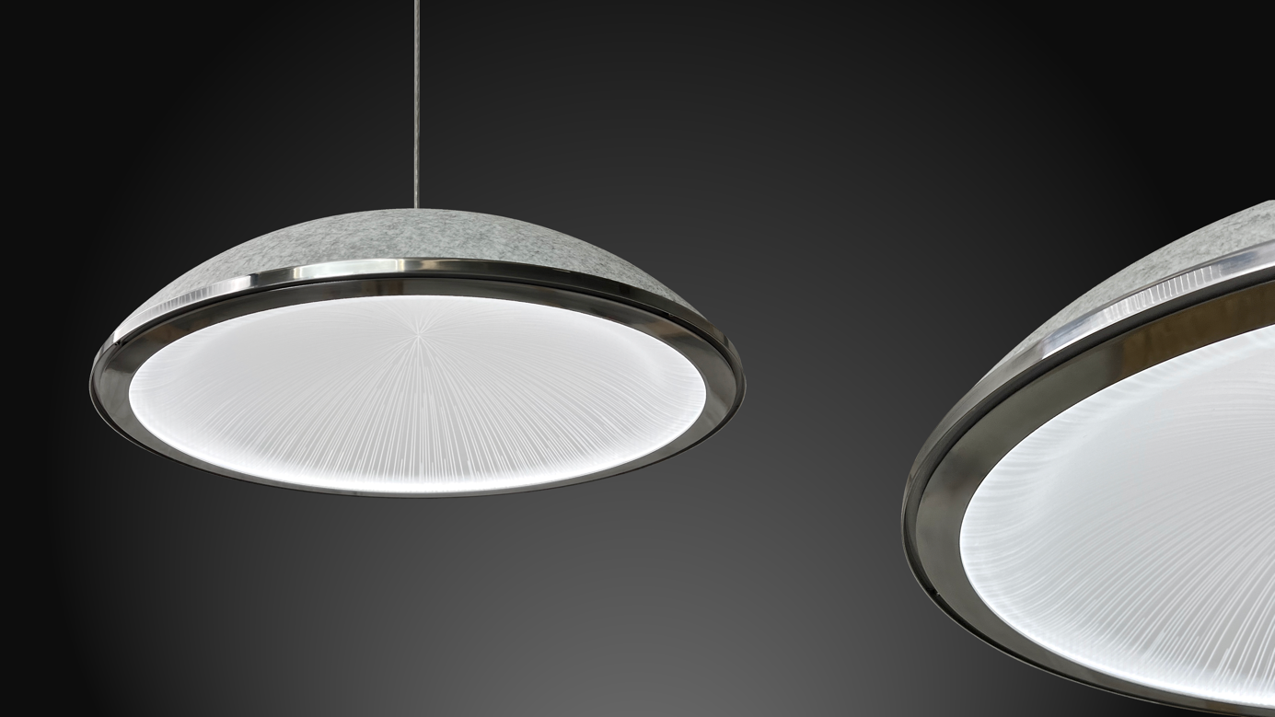

aKupolo | ‘Don’t take sound lightly’!

Light and acoustics are judged to be important factors in creating comfort & well-being. Studies have shown that the acoustics and the lighting of a space have a significant impact on productivity, as well as on how a space is experienced.
Where light and sound management meet, comfort & well-being are created!
ArchilumO has developed an acoustic lighting platform where function meets form, where beautifully designed lighting and acoustics help deliver optimally lit space conditions and balanced room acoustics that enhance well-being.
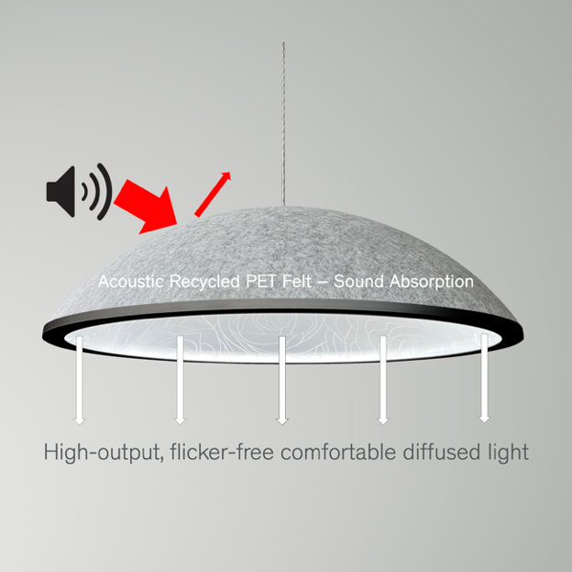
aKupolo | ‘You Create’!

A beautifully designed acoustic high performance light fixture that can be customised in Dimension (from 550mm -1150mm diameter), Ring Finish, Felt Dome Colour, Light Guide Etch Design and Control.

aKupolo | Models

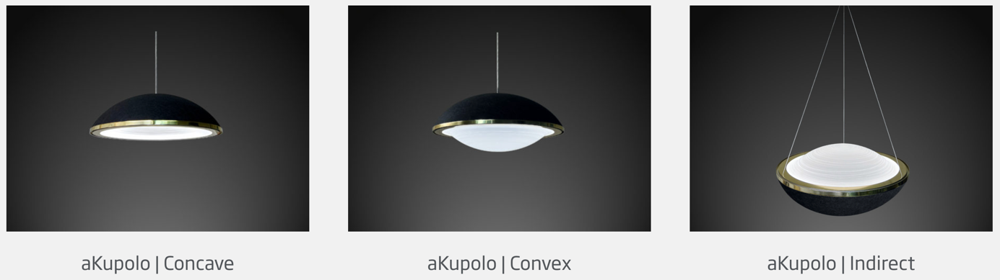

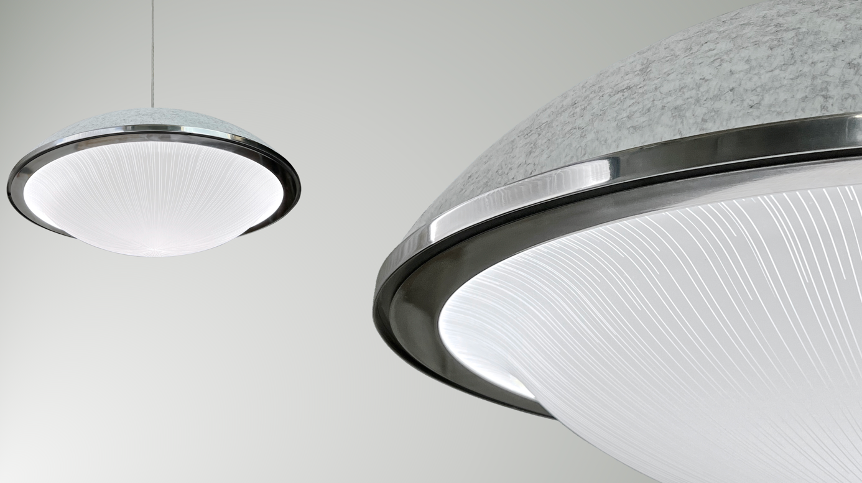

.

aKupolo | Dimensions

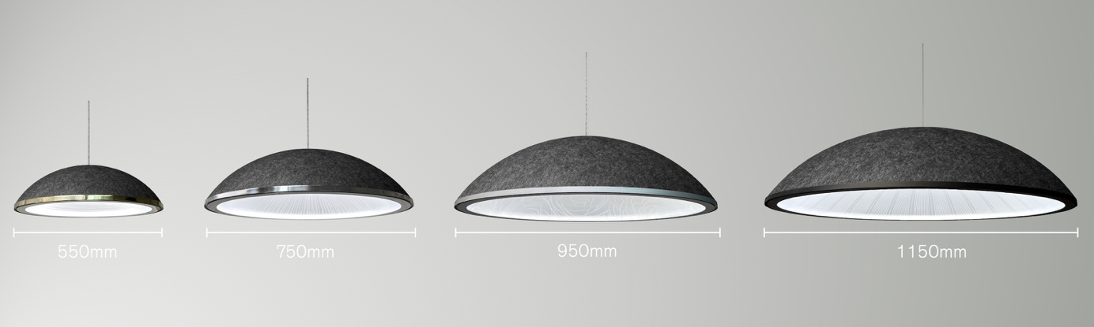

aKupolo | Design Options

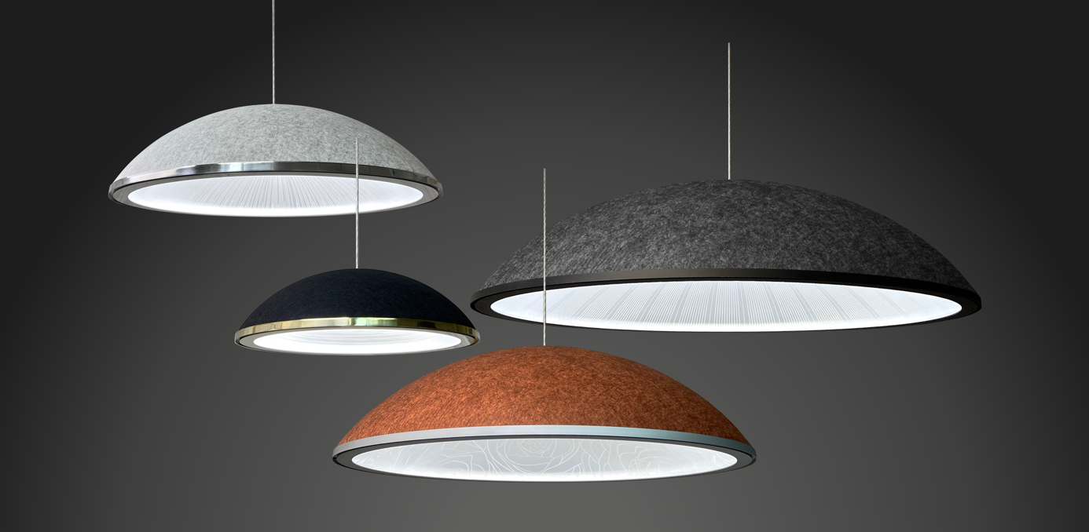

Acoustic Felt Colour Options

Choose from 6 colours 9mm Acoustic, Recycled, Fire retardant PET felt:

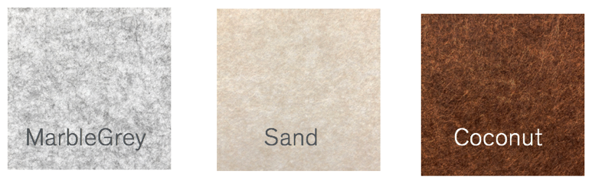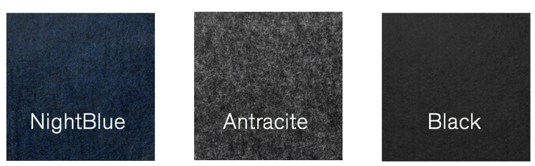

Ring Colours & Finishes

Select a matching ring:

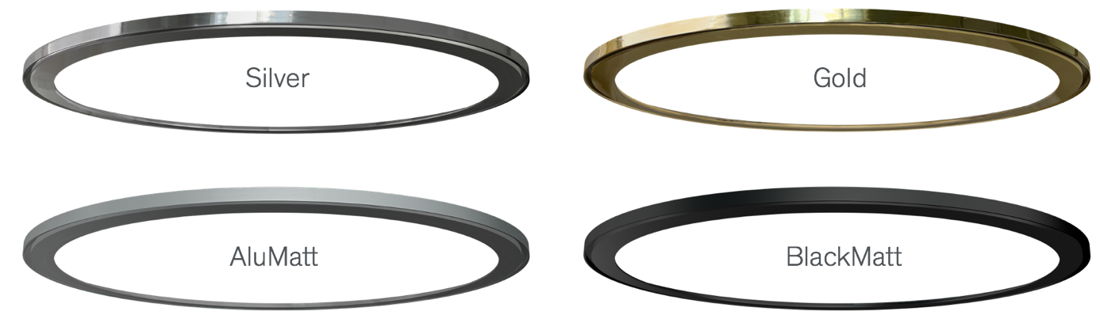

Light Guide | Etch-Designs

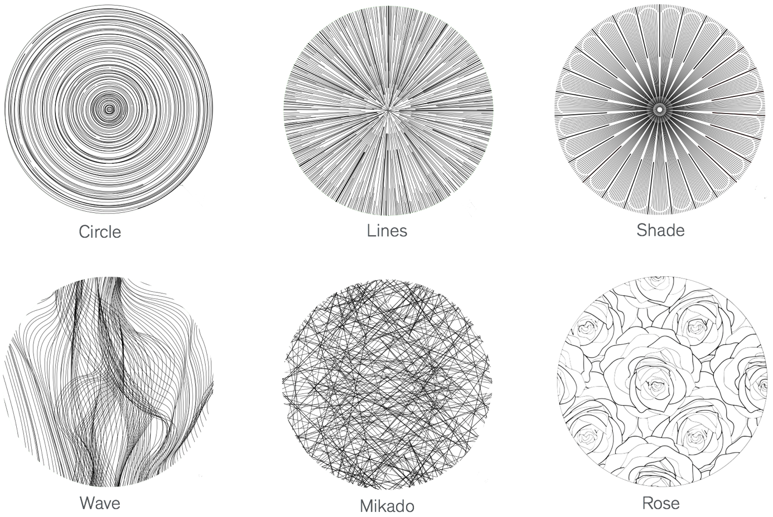

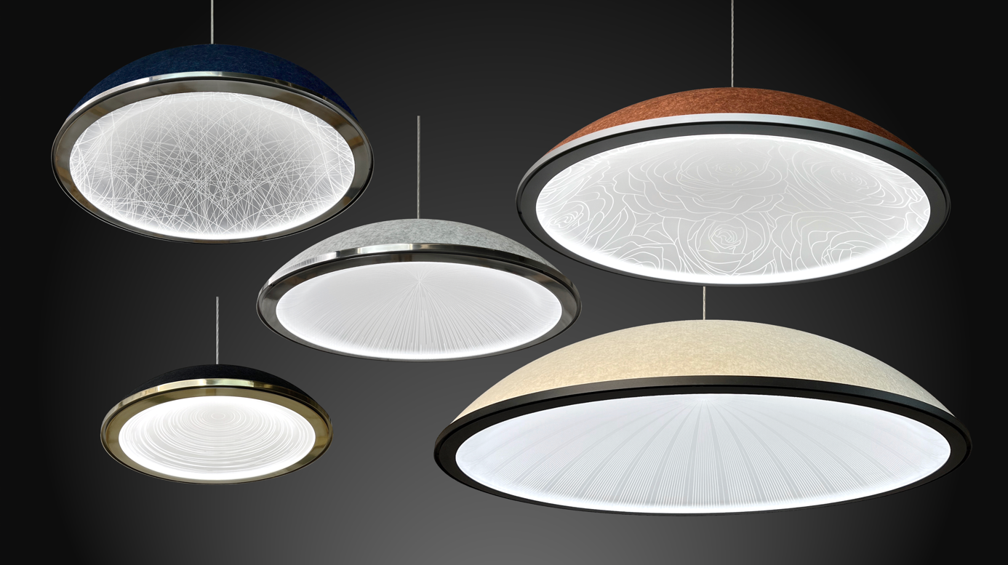

‘Where form meets function ‘- LED Options

All ArchilumO luminaires are made-to-order. For all products, Architects & Designers can choose from the widest range of flicker-free high-performance LED options. Select from 5 Standard White LED colours or opt for our wide range Tuneable White (2200-6500K) if you require the light to vary from ‘warm’ to ‘daylight’.

aKupolo delivers large volumes of comfortable diffused functional light.

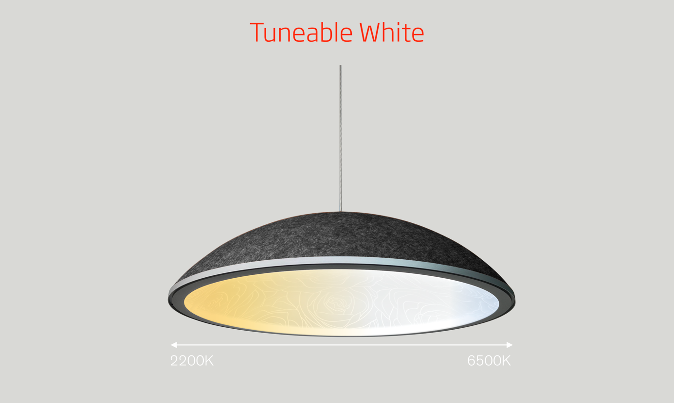

Single Whites

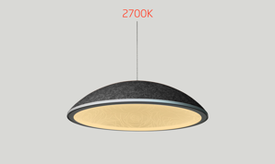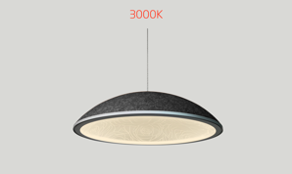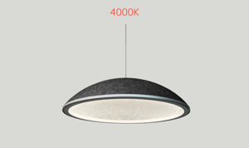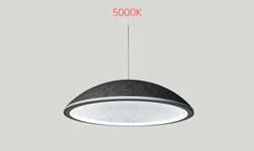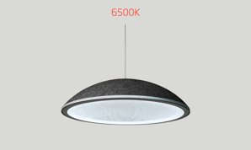

Unmatched Light Output - Tuneable White

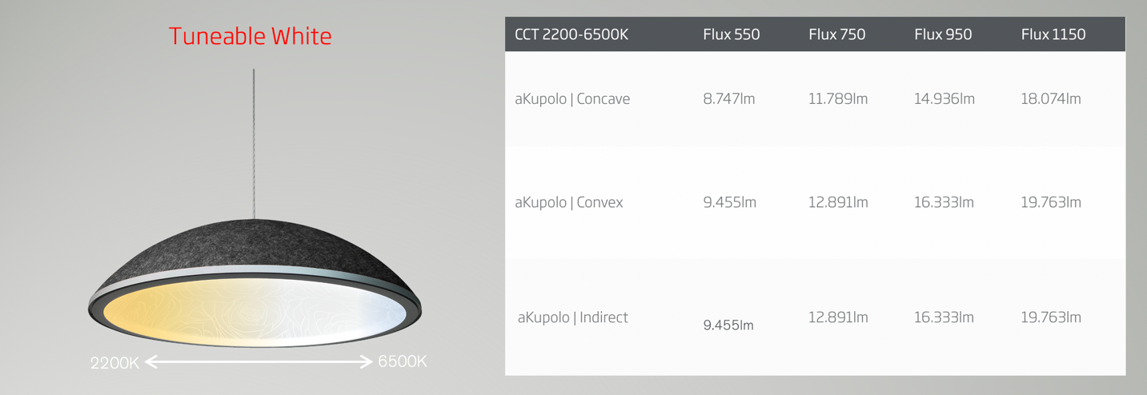

‘Where form meets function’ - Acoustic Performance

aKupolo is designed to excel from an acoustic, as well as a lighting perspective. The outer shell is made of recycled PET felt with outstanding acoustic/sound absorbing properties, whereas the inner dome – the acrylic Light Guide – produces large volumes of functional light. A carefully designed void between the felt outer shell and the Light Guide, enhances aKupolo’s acoustic performance to unmatched levels.

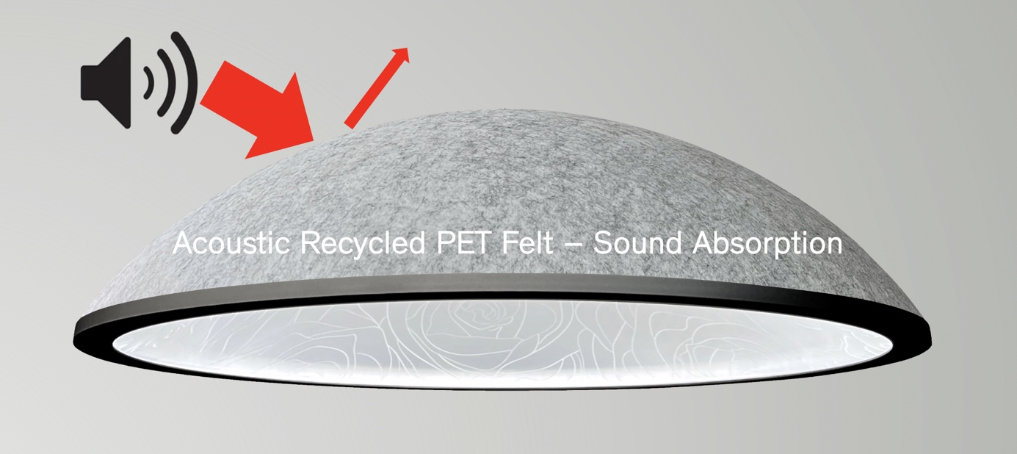

aKupolo is particularly effective in the Hertz zones that correspond with the human voice!

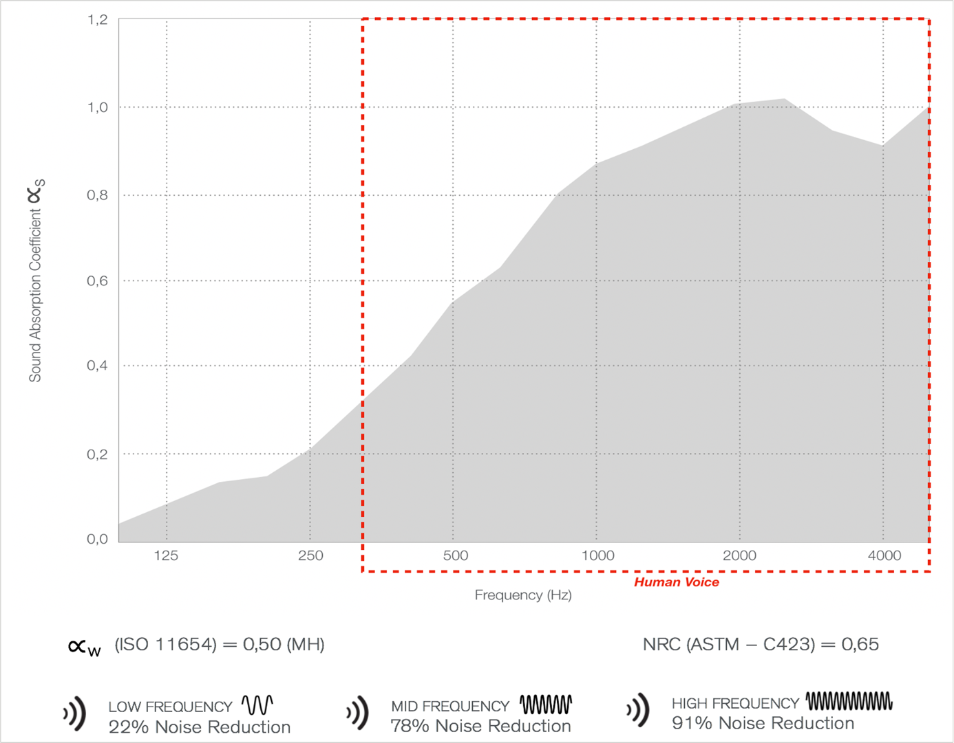
Lighting Control Technology

To control individual luminaires, groups of luminaires or entire installations, ArchilumO® has developed a proprietary DALI LED driver. Cutting edge technology has been applied in designing a top quality, high performance (480W) miniature DT6 and DT8 type LED driver that is integrated in the luminaire creating Individually Intelligent Lighting.

ArchilumO® is amongst the first to have programmed the driver firmware to the new DALI2 protocol (backward compatible). All ArchilumO® lighting products are DALI controlled and as a result, benefit from all available DALI control options such as the integration of DALI motion & daylight sensors, the creation of Human Centric Lighting scenes, the integration in Building Management Systems etc. aKupolo also has a Casambi control option.

To find out more about ArchilumO, visit www.archilumo.com

For more images and information, please contact:

Archilumo BV:
Cas Jongerius
Energieweg 21
NL- 1271EC Huizen
The Netherlands
T: +31(0) 6 512 44 770
E: cas@archilumo.com

Other available images:

